Multiple-choice section – choose the correct answer

Question 1 [6.1]

Which container has a smaller capacity than the oven tray and is taller than the mixing bowl?

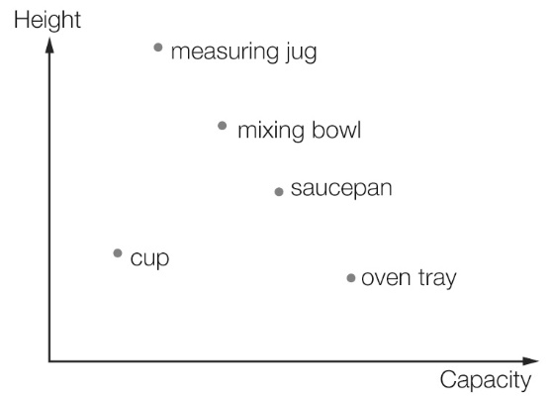

A cup B mixing bowl C saucepan D measuring jug

Question 2 [6.1]

The graph shows the travelling pattern of a family on a day’s journey. The family was travelling fastest towards their destination during:

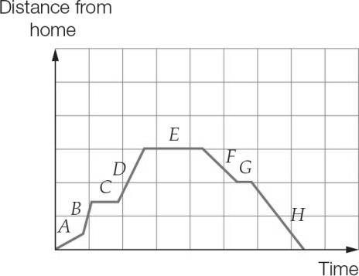

A Section *B* B Section *A* C Section *D* D Section *C*

Question 3 [6.2]

An ordered pair representing a point that is on the line *y* = -5 is:

A (0, -5) B (-2, 0) C (1, 1) D (0, 1)

Question 4 [6.2]

Which table matches the graph?

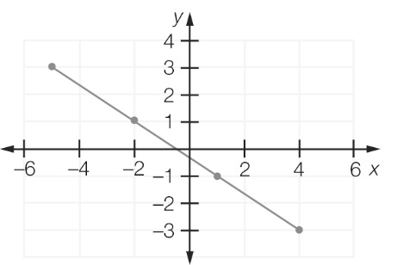

A

|  |  |  |  |  |
| --- | --- | --- | --- | --- |
| *x* | 3 | 1 | -1 | -3 |
| *y* | -4 | -1 | 2 | 5 |

B

|  |  |  |  |  |
| --- | --- | --- | --- | --- |
| *x* | 3 | -1 | -1 | -3 |
| *y* | -5 | -2 | 1 | 4 |

C

|  |  |  |  |  |
| --- | --- | --- | --- | --- |
| *x* | -4 | -1 | 2 | 5 |
| *y* | 3 | 1 | -1 | 3 |

D

|  |  |  |  |  |
| --- | --- | --- | --- | --- |
| *x* | -5 | -2 | 1 | 4 |
| *y* | 3 | 1 | -1 | -3 |

Question 5 [6.2]

Which point lies on the graph *x* = -3?

A (1, 0) B (-3, 2) C (-1, -3) D (3, 0)

Question 6 [6.3]

(1, 3), (2, 7), (3, 11) and (4, 15) are coordinates of points which lie on the line with rule:

A *y* = 4*x* – 1 B *y* = 5*x* – 2 C *y* = 3*x* D *y* = 2*x* + 1

Question 7 [6.2]

The coordinates of a point that lies on the graph of  are:

A (1, 2) B (2, 3) C (3, 9) D (4, 14)

Question 8 [6.2]

The *x*-intercept of the line with the equation  is:

A (1, 0) B (2, 0) C (-1, 0) D (-2, 0)

Question 9 [6.2]

The gradient of which of the following lines is not defined?

A *x* = 5 B *x* = *y* C *x* + *y* = 1 D *y* = 1

Question 10 [6.2]

The ordered pair (-2, 1) lies on which of the following lines?

A *x* + *y* = 4 B 2*x* + *y* = 4 C *x* +3*y* = 1 D 3*x* + *y* = -1

Question 11 [6.2]

The line given by the equation :

A has a gradient of zero B is flat

C is very steep D is not very steep

Question 12 [6.4]

An electrician charges $55 for a callout and then $25 per hour of work. If *C* represents the total cost in dollars and *t* represents the time the electrician works in hours, the following table of values can be constructed.

|  |  |  |  |  |  |
| --- | --- | --- | --- | --- | --- |
| *t* | 0 | 2 | 4 | 6 | 8 |
| *C* | 55 | 105 | 155 | 205 | 255 |

If the electrician worked for 7 hours, the cost is approximately:

A $60 B $100 C $230 D $250

Multiple-choice results: ___ /12

Short answer section

Question 13 5 marks [6.2]

Use words from the list below to complete the following sentences.

*origin straight line slope negative gradient x-axis*

*positive linear left y-intercept slope Cartesian*

(a) The ______________ of a line is a measure of its steepness.

(b) Lines with a _________________ gradient ______________ up to the right and lines with a   
____________ gradient _____________ up to the ______________.

(c) The point (0, 0) is the _______________ of the _______________ plane.

(d) The *x*-intercept is where a line crosses the ___________________ and the ___________________is where a line crosses the *y*-axis.

(e) When points on a graph make a ______________________then the relationship between the variables is _______________.

Question 14 2 marks [6.2]

Find the equations of the horizontal and vertical lines passing through the point (-3,-2).

Question 15 3 marks [6.1]

Use the graph below to answer the following questions.

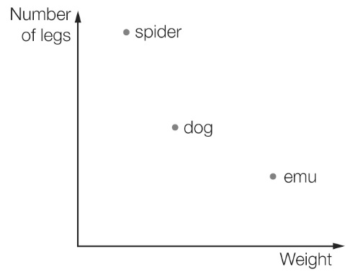

(a) What are the two variables shown in the graph?

(b) Which animal has more legs than the emu and weighs less than the dog?

(c) Which animal is the heaviest?

Question 16 2 marks [6.1]

The Spanos family is travelling by car to their holiday destination. The following graph shows the distance they are from home.

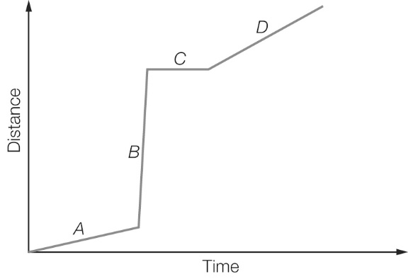

(a) In which section of the graph (*A, B, C* or *D*) are they travelling the fastest?

(b) In which section did they stop?

Question 17 3 marks [6.2]

Complete the table of values for the rule *y* = 3*x* – 2.

|  |  |  |  |  |  |  |  |
| --- | --- | --- | --- | --- | --- | --- | --- |
| *x* | -3 | -2 | -1 | 0 | 1 | 2 | 3 |
| *y* |  |  |  |  |  |  |  |

Question 18 4 marks [6.3]

Find the equation which describes the following relationship by creating a table of values  
from *x* = -3 to *x* = 3.

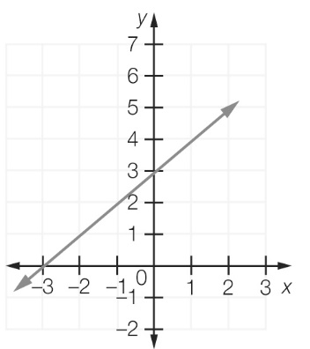

|  |  |  |  |  |  |  |  |
| --- | --- | --- | --- | --- | --- | --- | --- |
|  |  |  |  |  |  |  |  |
|  |  |  |  |  |  |  |  |

Question 19 6 marks [6.3]

Plot the following points on the Cartesian plane below. Join the points with a straight line then find the *y*-intercept and the rule that relates *x* and *y*.

(a) (0, 4), (-2, 2) (b) (1, 0), (2, 2)

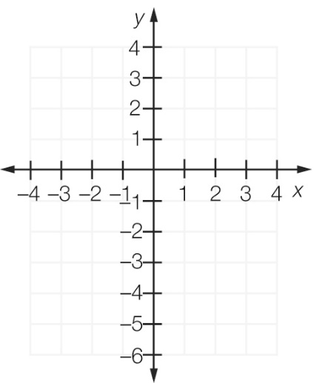

Question 20 4 marks [6.3]

Write the equation of each of the following lines.

(a)

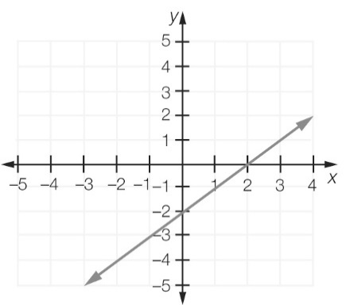

(b)

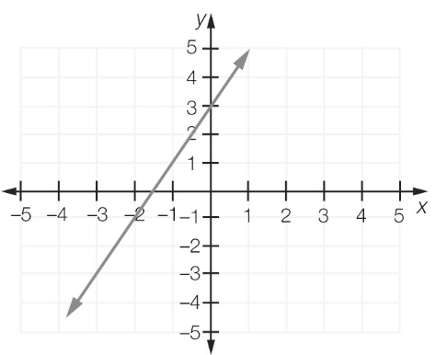

Question 21 2 marks [6.2]

Find the *x*-intercept and *y*-intercept for the line 

Question 22 3 marks [6.2]

Graph the lines *x* = -2 and *y* = 4 on the same set of axes. Use the graphs to find the point of intersection.

Question 23 1 mark [6.3]

What is the equation of the line that is parallel to the *x*-axis and passes through the point (-4, 3)?

Question 24 1 mark [6.3]

What is the equation of the line that is parallel to the *y*-axis and passes through the point (-2, 5)?

Short answer results: ___ / 36

Extended answer section

Question 25 5 marks [6.1]

A family went for a long drive in a car. At the start of the trip the petrol tank contained 90 L of petrol and was full. After driving 600 km they bought 60 L of petrol to fill the tank. After another 500 km they bought 65 L and this brought the amount of petrol in the tank up to 85 L.

(a) Complete the table of values showing how much petrol was in the tank at different distances on the trip.

|  |  |  |  |  |  |
| --- | --- | --- | --- | --- | --- |
| Distance from start (km) | 0 | 600 | 600 | 1100 | 1100 |
| Petrol in tank (L) |  |  |  |  |  |

(b) Use your table in (a) to plot a graph of the amount of petrol in the tank.

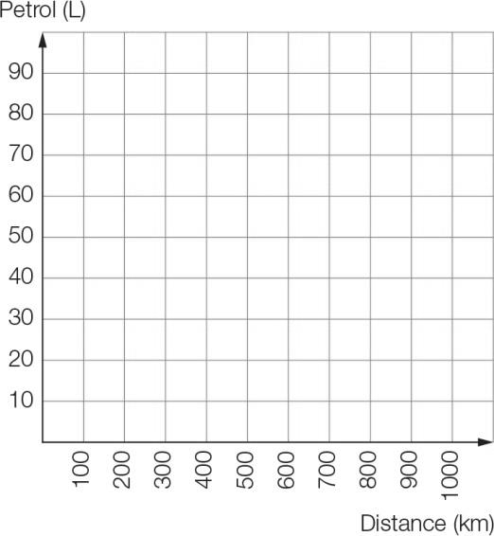

(c) Compare the rate that petrol is being used for the two parts of the trip (in litres per 100 km).

(d) How is the answer to (c) shown on the graph?

Question 26 5 marks [6.3]

The following shapes have been made with matchsticks.

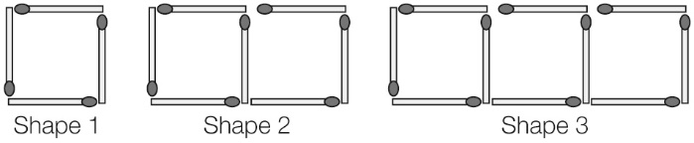

(a) Complete this table of values.

|  |  |
| --- | --- |
| Number of squares  (*s*) | Number of matches  (*m*) |
| 1 | 4 |
| 2 | 7 |
| 3 |  |
| 4 |  |
| 5 |  |

(b) Find the pattern, or rule, that links *s* to *m.*

(c) Plot each pair of values then join the points with a straight line.

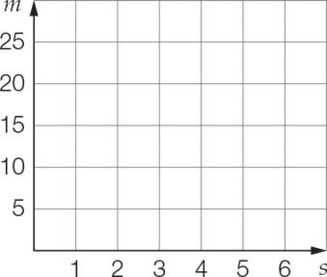

(d) Use the rule you found in (b) to find the number of matches needed to build 12 squares.

Question 27 4 marks [6.3]

A car repair company charges a $30 fee to attend for the repair and then $20 per hour for the time spent on the repair.

(a) Find a rule for calculating the cost *C* in terms of time spent on repairs *t*.

(b) Draw a linear graph of *C* against *t*.

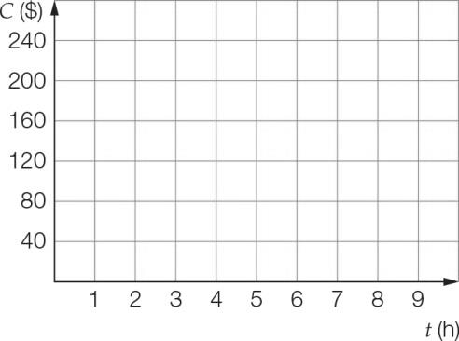

(c) How much will you pay if your car is repaired in  hours?

Question 28 4 marks [6.4]

The toll on the recently completed Radnor bridge is charged as follows:

Each vehicle is charged $1.80 and each occupant in a vehicle is charged $0.25.

(a) What is the toll for a vehicle with one occupant?

(b) What is the rule for the toll *T* in terms of the number of occupants *p*?

(c) What is the toll for a vehicle carrying 20 occupants?

Question 29 5 marks [6.4]

When you convert measurements in inches to millimetres, 1 inch is the same as 25 millimetres.

(a) Use the statement above to complete this table of values of inches and millimetres.

|  |  |  |  |  |  |  |  |
| --- | --- | --- | --- | --- | --- | --- | --- |
| Number of inches | 0 | 1 | 2 | 3 | 4 | 5 | 10 |
| Number of millimetres |  |  |  |  |  |  |  |

(b) Using *n* for the number of inches and *m* for the number of millimetres, write a rule showing the relationship.

(c) Draw a graph of this relationship for numbers of inches up to 10.

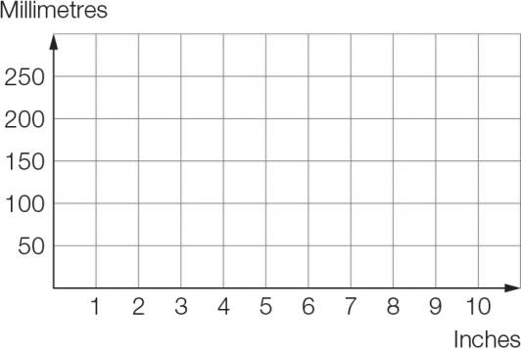

(d) Use an appropriate method to convert 1 inches to millimetres.

(e) How many inches are there in 1 metre?

Extended answer results: ___ / 23

TOTAL test results: ___ / 71